**Build Profile:**

* + These are set of configuration values which can be used to set or override the default values
  + Types of Build Profile:
    - Per Project => project’s pom.xml
    - Per User => (HOME-DIRECTORY/.m2/settings.xml)
    - Global => Defined in th M2_HOME/conf/settings.xml

**Maven Repository**

* In Maven, repository is a directory where all the project jars, library or any other project specific artifacts can be stored. Generally, we will have dependencies and our project’s jar and pom.xml files stored in repository 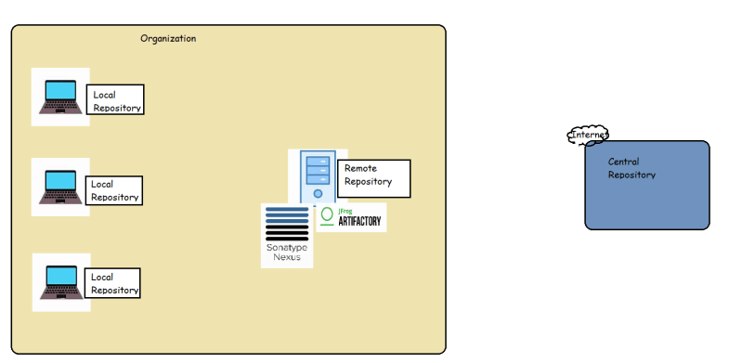
* Maven repositories are of three types
  + local
  + remote
  + central
* Central repository: This is repository maintained by Maven community and has large number of commonly used libraries. when maven doesnot find the dependency in your local repo it will start searching in central repo [Refer Here](https://repo1.maven.org/maven2/) <https://repo1.maven.org/maven2/> and if found downloads to your local repository
* Remote Repository: This repository will be maintained by our organization to have the libararies developed and build daily. All the developers in our organization can start using the libraries developed by other teams/individuals by adding dependencies to the the current project pom

<project>

...

<repositories>

<repository>

<id>qt.general</id>

<url>https://download.qt.com/maven2/general</url>

</repository>

</repositories>

</project>

* Skills for DevOps Engineers Required w.r.t build tools
  + How to configure/resolve dependency
* maven => central repo => pom.xml <dependencies>
* .net => nuget => packages.json/packages.config in the project
* node js => npm => npm install
* python => pip => requirements.txt => pip install -r requirements.txt
  + Get to know the commands
  + How to execute unit tests and where will be the test reports?
  + How to store artifacts into some repository